# Change Request Form

| **Change Request No.:** | CR2023-0001 | | | | | | |
| --- | --- | --- | --- | --- | --- | --- | --- |
| **Project Details** | | | | | | | |
| **Project Name:** | Nexelus | | | | | | |
| **Module/Area:** | Web | AP Workflow | | IPC | | | Other |
| **Specify Other:** |  | | | | | | |
| **Change Request Details** | | | | | | | |
| **Requested By:** | Asim Jameel | | | | | | |
| **Date of Request:** | 4/6/2023 | | | | | | |
| **Specify Details:** | Change Request: Hide DOB on Employee Screen | | | | | | |
| **Priority:** | Urgent | | Normal | | Low | Other | |
| **Implementation Time:** | 1 Hour | | | | | | |
| **Change Request Approval Details** | | | | | | | |
| **Approval:** | Approved | | Postponed | | Rejected | | |
| **Reason for Decision:** | Internal Discussion | | | | | | |
| **Approver/Date:** | Asim Jameel - 4/6/2023 | | | | | | |
| **Closing Details (To be filled by GM Development/Principal Software Engineer)** | | | | | | | |
| **Closed By:** | <Name> | | | | | | |
| **Closing Date:** | <Date> | | | | | | |
| **Status:** | Completed | | Postponed | | Terminated | | |

## Priority of Change Implementation

Priority of Change Implementation in the change request details can be interpreted as follows:

* **Urgent** - Implementation Time is 1 Day
* **Normal** - Implementation Time is 3 Days
* **Low** - Implementation Time is 1 Week
* **Other** - Implementation Time is more than 1 Week

## Reason for Change

AS we are currently working on SOC2 compliance and based on SOC2, Nexelus must protect User’s personal data by ensuring that data is encrypted and not accessible by any unauthorized person.

Nexelus doesn’t store any personal sensitive data in Nexelus except DOB.

DOB is not required for any Nexelus feature, that’s why we can remove this field from Employee UI.

## Description of Change

Nexelus will hide DOB field from Employee Scree, hiding is goo­­­d enough, we don’t need to remove filed from Code / Database,

Furthermore, We need to check all client’s data and remove DOB from database if it is saved against any employee.

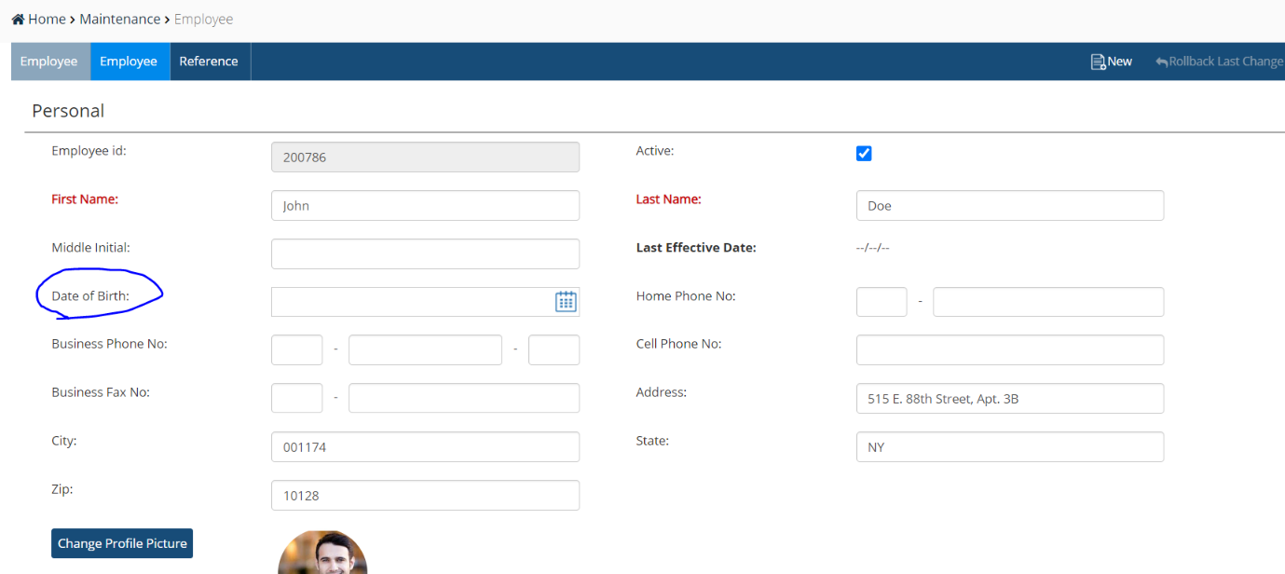

## Impact Analysis Details

Following are the impacts of the change in different modules:

| **Modules** | **Sub-Modules** | **Impact Details (What is the impact?)** | **Impact Level** |
| --- | --- | --- | --- |
| Nexelus | Employee |  | No Impact |

**Impact Level:** Significant, Negligible, No Impact

**Implementation Time: 1 Hour**

**QA Time: 30 minutes**

**Description:**

Aspx Page UI change only.